LAB ACTION PLAN FOR WEEK 10

Working with minikube and Nagios
- Hands-on practice of creating, running and scaling pods in minikube.
- Running Nginx server on specified port number by explaining the Nginx monitoring tool
- Running Nagios server and Understanding the Monitoring tool using Docker.
- AWS-free Trier account Creation steps
- Upload the screenshots for the tasks
Kubernetes:
Kubernetes is a tool that automates how we run and manage applications inside the container.
Dockers will only run containers, if in any case the container fails/stopped/killed, the docker will not help us, here is where Kubernetes plays an important role, Kubernetes cluster will be responsible in creating a new container and managing various containers.
POD: In Kubernetes, a Pod is the smallest deployable unit that you can create and manage.
Minikube:
Minikube creates a VM on your local machine and deploys a simple Kubernetes cluster with one node. It's a lightweight implementation.Minikube is a version of Kubernetes.
Nagios:
Nagios is an open-source IT infrastructure monitoring tool. It monitors
- Serrvers
- Network devices
- Applications and services
It alerts admnistrators when issues occur and notifies when they are resolved.

Step 1: Install Prerequisites
Before installing Minikube, ensure the following are installed:
- Virtualization Support:
  - Verify virtualization is enabled:
- Hypervisor:
  - Minikube supports multiple hypervisors (e.g., Hyper-V, VirtualBox, or Docker as a driver).
  - Install one of the following:
    - Hyper-V (pre-installed on Windows 10/11 Pro or Enterprise).
    - Docker Desktop (if you want to use Docker as the driver).

Step 2: Download Minikube
- Open a PowerShell or Command Prompt with administrator privileges.
- Download the latest Minikube executable using this command:
- curl -LO https://storage.googleapis.com/minikube/releases/latest/minikube-installer.exe
- Install Minikube by running the installer:
- .\minikube-installer.exe

Step 3: Add Minikube to PATH
If Minikube is not automatically added to your PATH during installation:
- Open System Properties → Environment Variables.
- Add the directory where Minikube is installed (e.g., C:\Program Files\Minikube) to your PATH variable.

Step 4: Start Minikube
- Open a terminal (PowerShell or CMD). Do the following commands
- Start Minikube with a specified driver (e.g., Hyper-V, Docker, or VirtualBox). For example:
  - Hyper-V:
  - minikube start --driver=hyperv
  - Docker:
  - minikube start --driver=docker
- Verify Minikube is running:
- minikube status

Step 5: Interact with Minikube

kubectl is a command-line tool used in Kubernetes to interact with and manage Kubernetes clusters.
Once Minikube is running:
- Use kubectl to interact with the cluster.
  - Install kubectl if not already installed:
  - minikube kubectl -- get pods -A
  - Or download it separately from the official Kubernetes site.
- Open the Minikube dashboard (optional):
- minikube dashboard

Optional: Check Your Installation
Run the following to verify the installation:
Minikube version
kubectl version --client

Troubleshooting
- If Minikube fails to start:
  - Ensure your hypervisor (Hyper-V/Docker/VirtualBox) is installed and running.
  - Check the Minikube logs:
  - minikube logs
- Updating Minikube:
- minikube update-check
- minikube update

Minikube Automation Steps

Step 1: Start Minikube Cluster
- Open your terminal and run the command:
minikube start
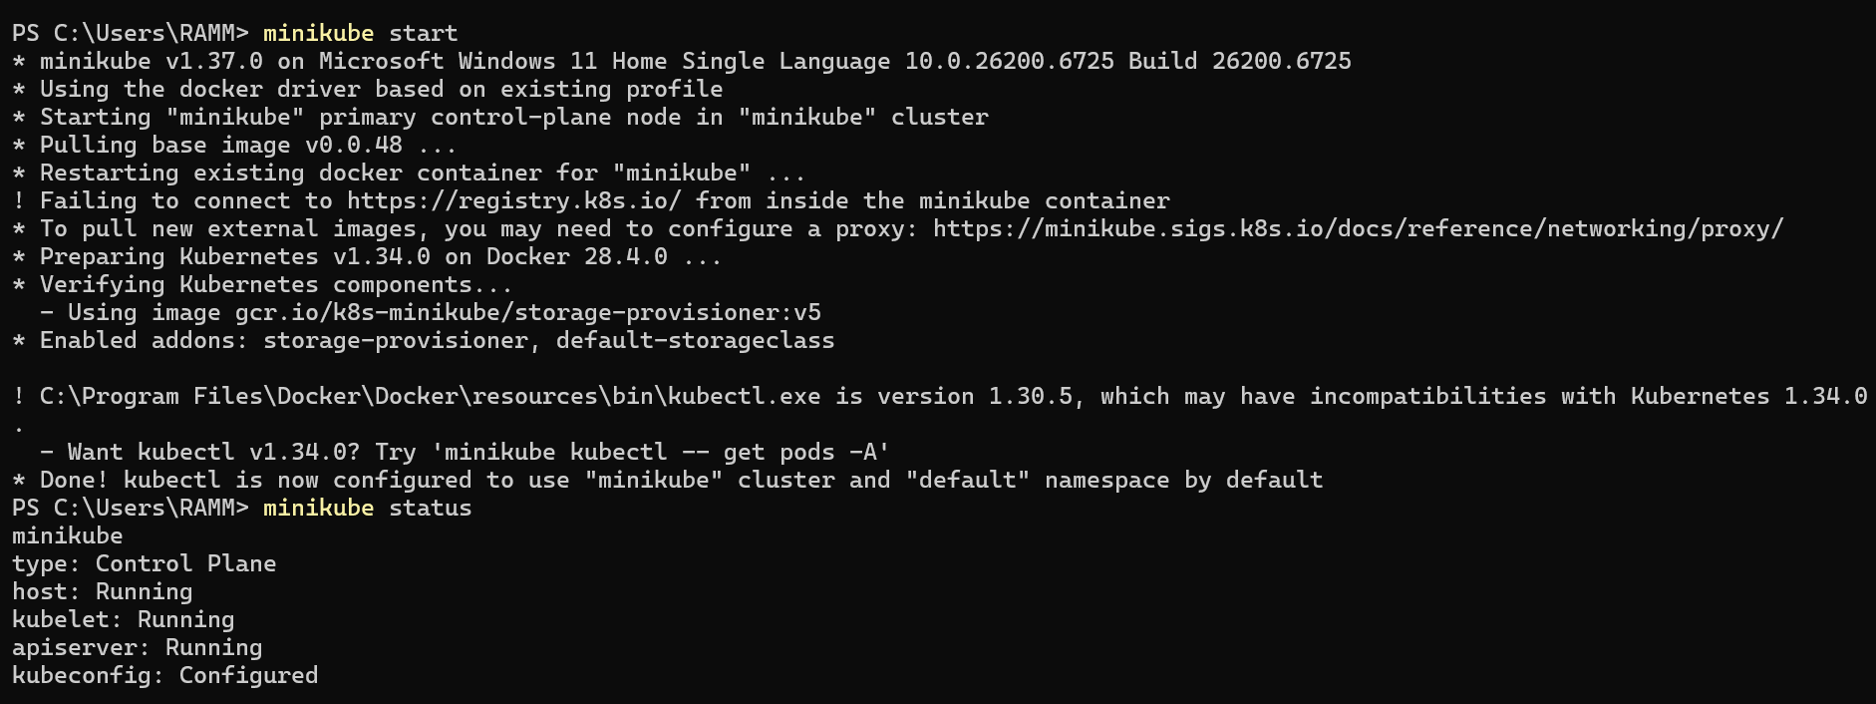

Step 2: Create and Manage Deployment
- Create an application in Kubernetes:
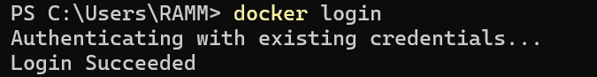
  - Command:
kubectl create deployment mynginx --image=nginx

if already created then
kubectl set image deployment/myngnix nginx=nginx:latest
Verify the deployment using: Kubernetes responds by showing you a list that includes the names of your deployment groups
kubectl get deployments
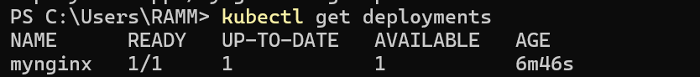
    - Ensure mynginx appears in the output.
Check the following commands:
  - kubectl get pods
  - kubectl describe pods
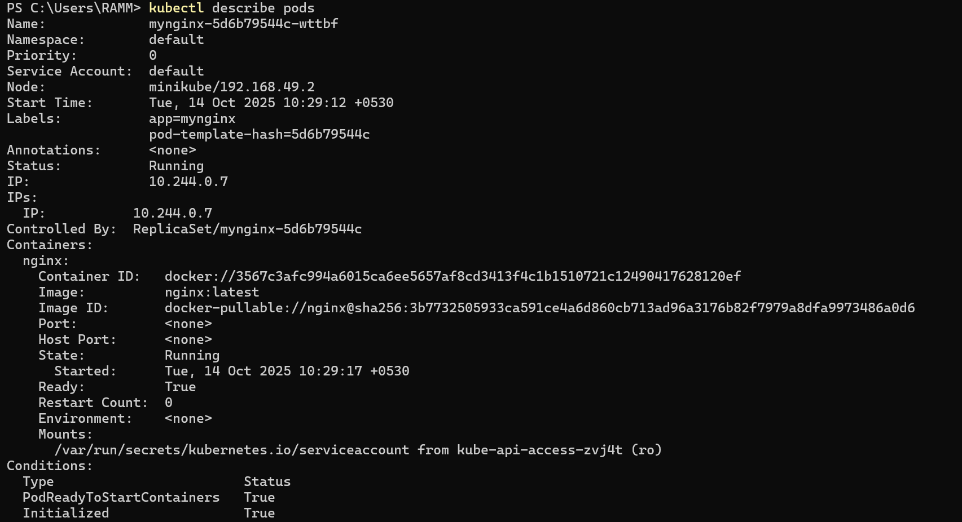
- Expose Deployment as a Service:
  - Command:
kubectl expose deployment mynginx --type=NodePort --port=80 --target-port=80

Step 3: Scale the Deployment
Command:Scales the Nginx deployment to 4 replicas (pods).
kubectl scale deployment mynginx --replicas=4

kubectl get service myngnix

Step 4: Access the Nginx App
- Using Port Forwarding:
  - Command:
kubectl port-forward svc/mynginx 8081:80
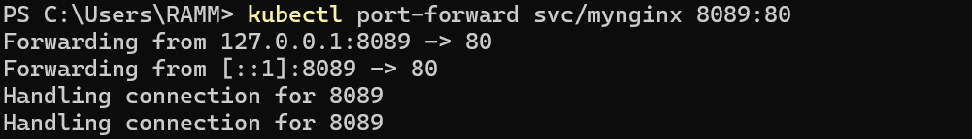
    - Access the app via http://localhost:8081.
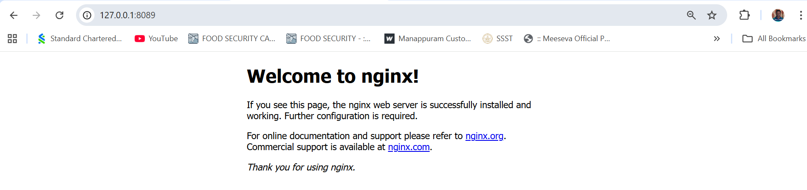
If Error, use this option, Using Minikube Tunnel:
  - Start the tunnel:
minikube tunnel
  - Retrieve the service URL:
minikube service mynginx --url
  - Open the provided URL in your browser.
  - Open the kubernets dashboard
- Open the minikube dashboard
Minikube dashboard
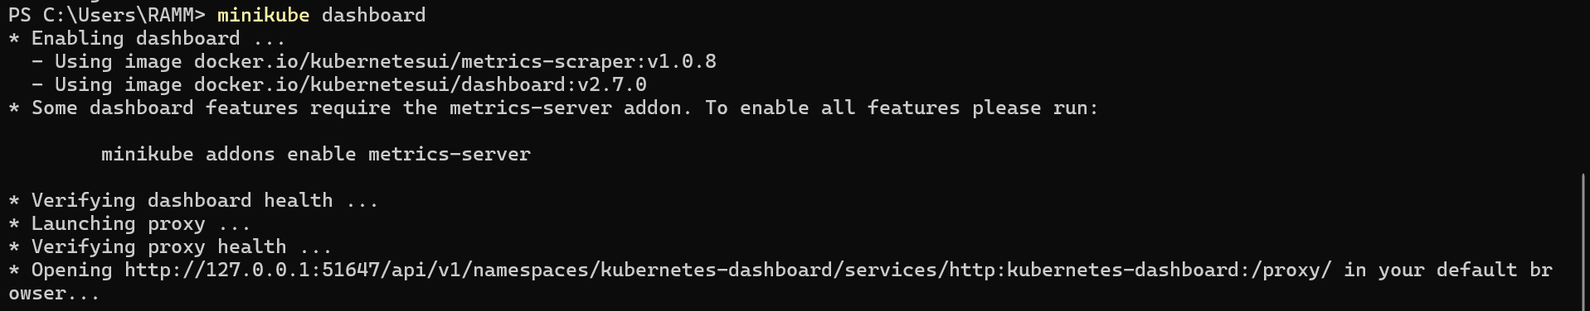
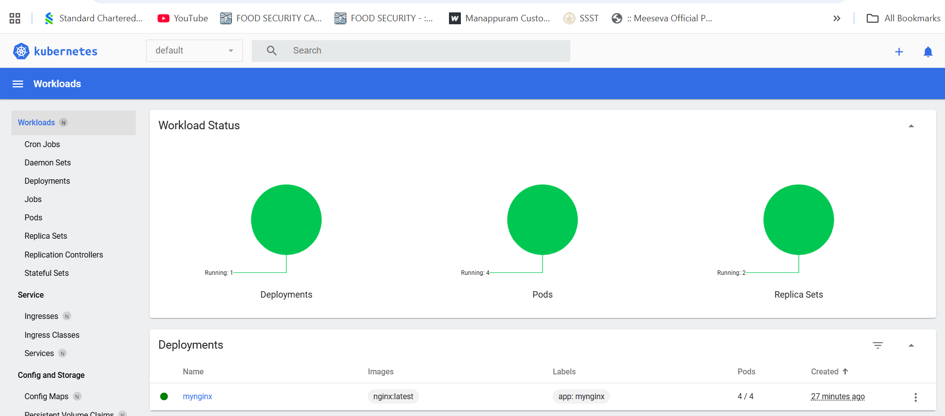
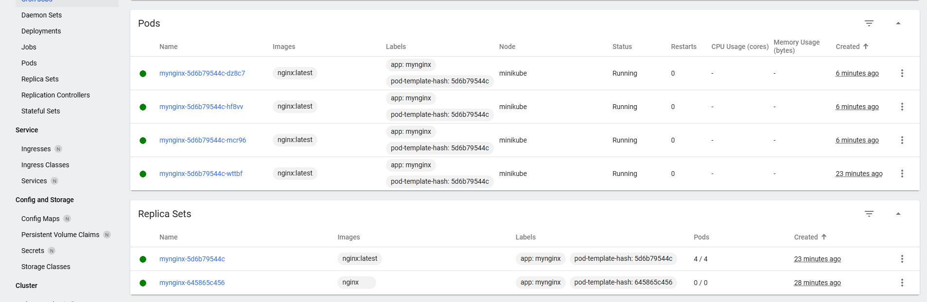

Step 5: Stop and Clean Up
- Stop Nginx Deployment:
  - Commands:
kubectl delete deployment mynginx
kubectl delete service mynginx
- Stop Minikube (Optional):
  - Command:
minikube stop
- Delete Minikube Cluster (Optional):
  - Command:minikube delete
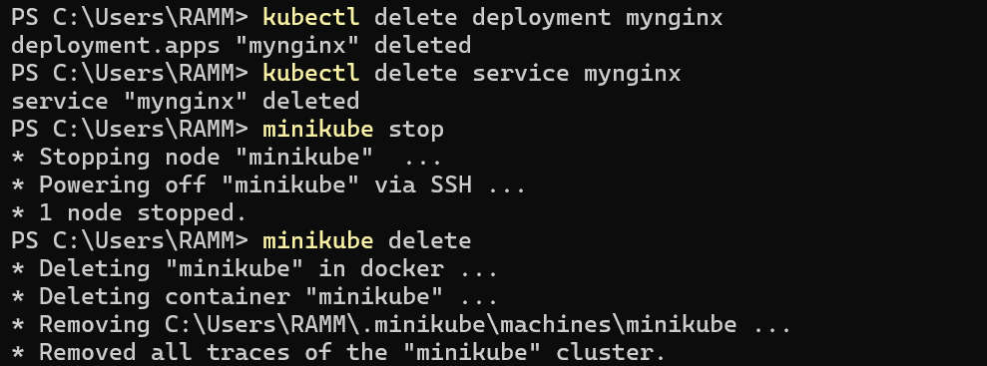

Nagios Automation Steps

Step 1: Pull the Nagios Docker Image
- Open a terminal and run:
docker pull jasonrivers/nagios:latest
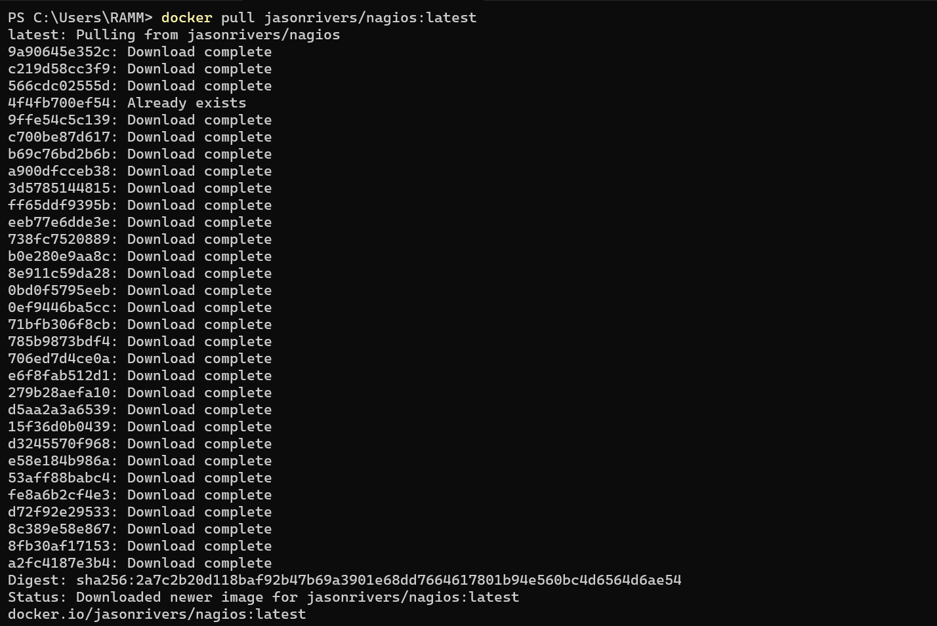

Step 2: Run Nagios
- Command:
docker run --name nagiosdemo -p 8888:80 jasonrivers/nagios:latest
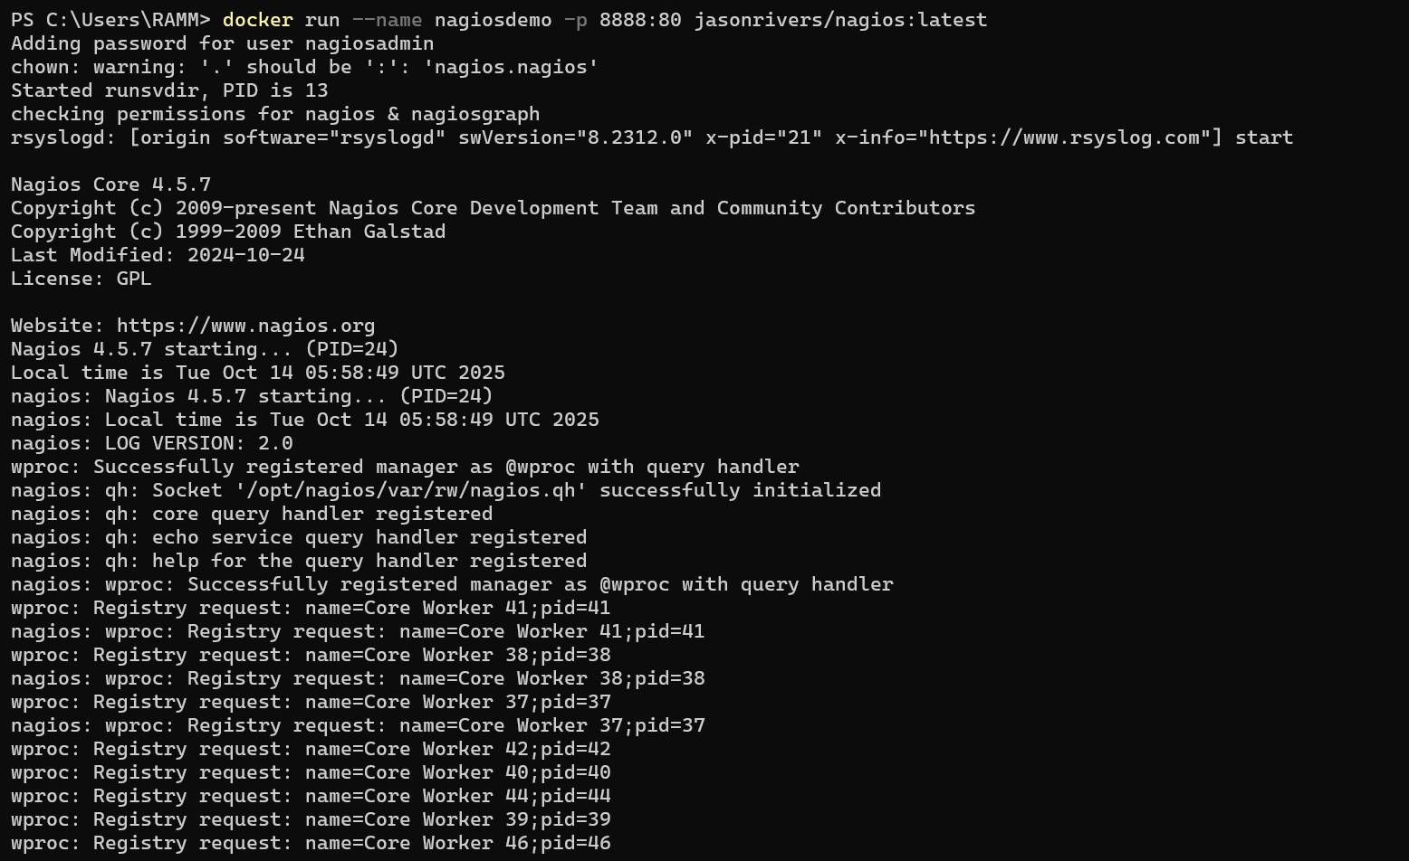

Step 3: Access Nagios Dashboard
- Open your browser and navigate to:
http://localhost:8888
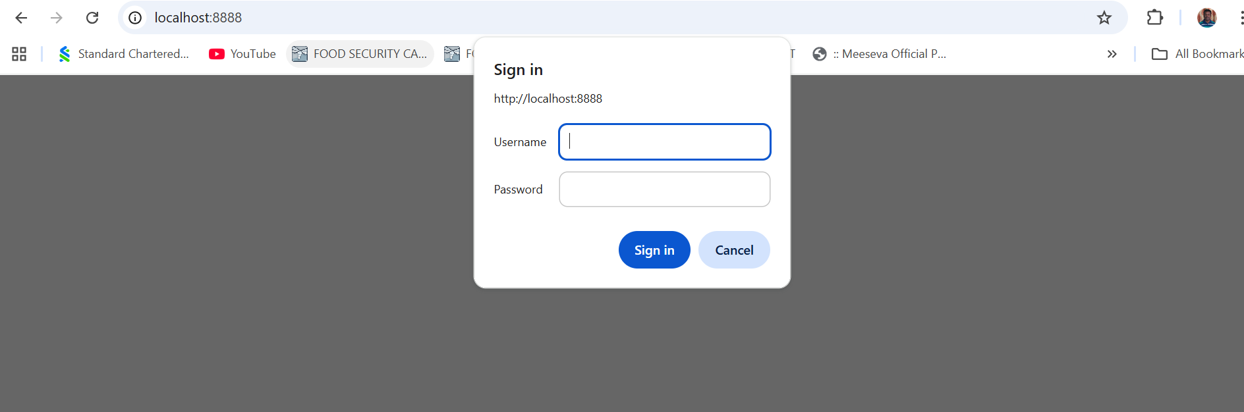
  - Login Credentials:
    - Username: nagiosadmin
    - Password: nagios
  - Once logged in, explore:
    - Hosts: View systems being monitored.
    - Services: Check tasks being monitored (e.g., CPU usage).
    - Alerts: Access recent notifications.
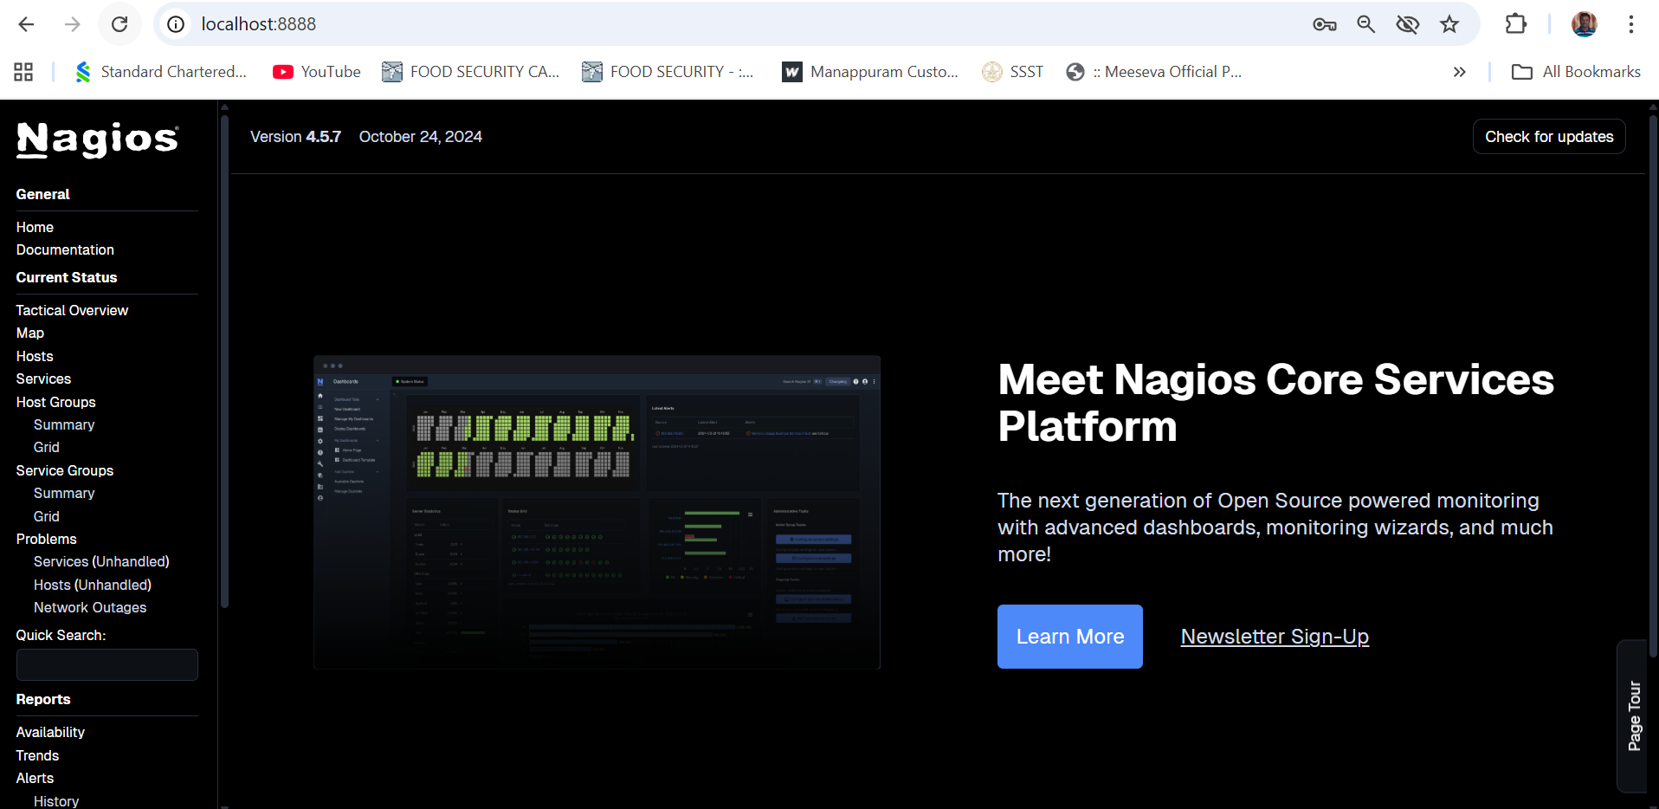

Step 4: Monitoring Host Details
- Navigate to the Host Information Page:
  - Select a host from the Hosts menu.
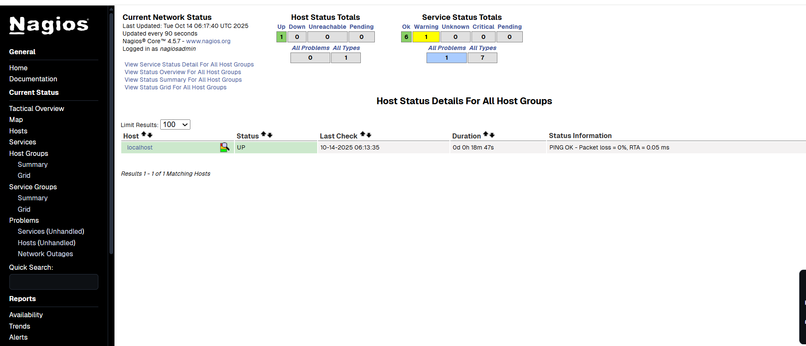
- Key Details:
  - Host Status: Indicates if the system is UP or DOWN.
  - Metrics: View CPU usage, memory status, and network activity.
  - Actions: Reschedule checks, disable notifications, or schedule downtime.
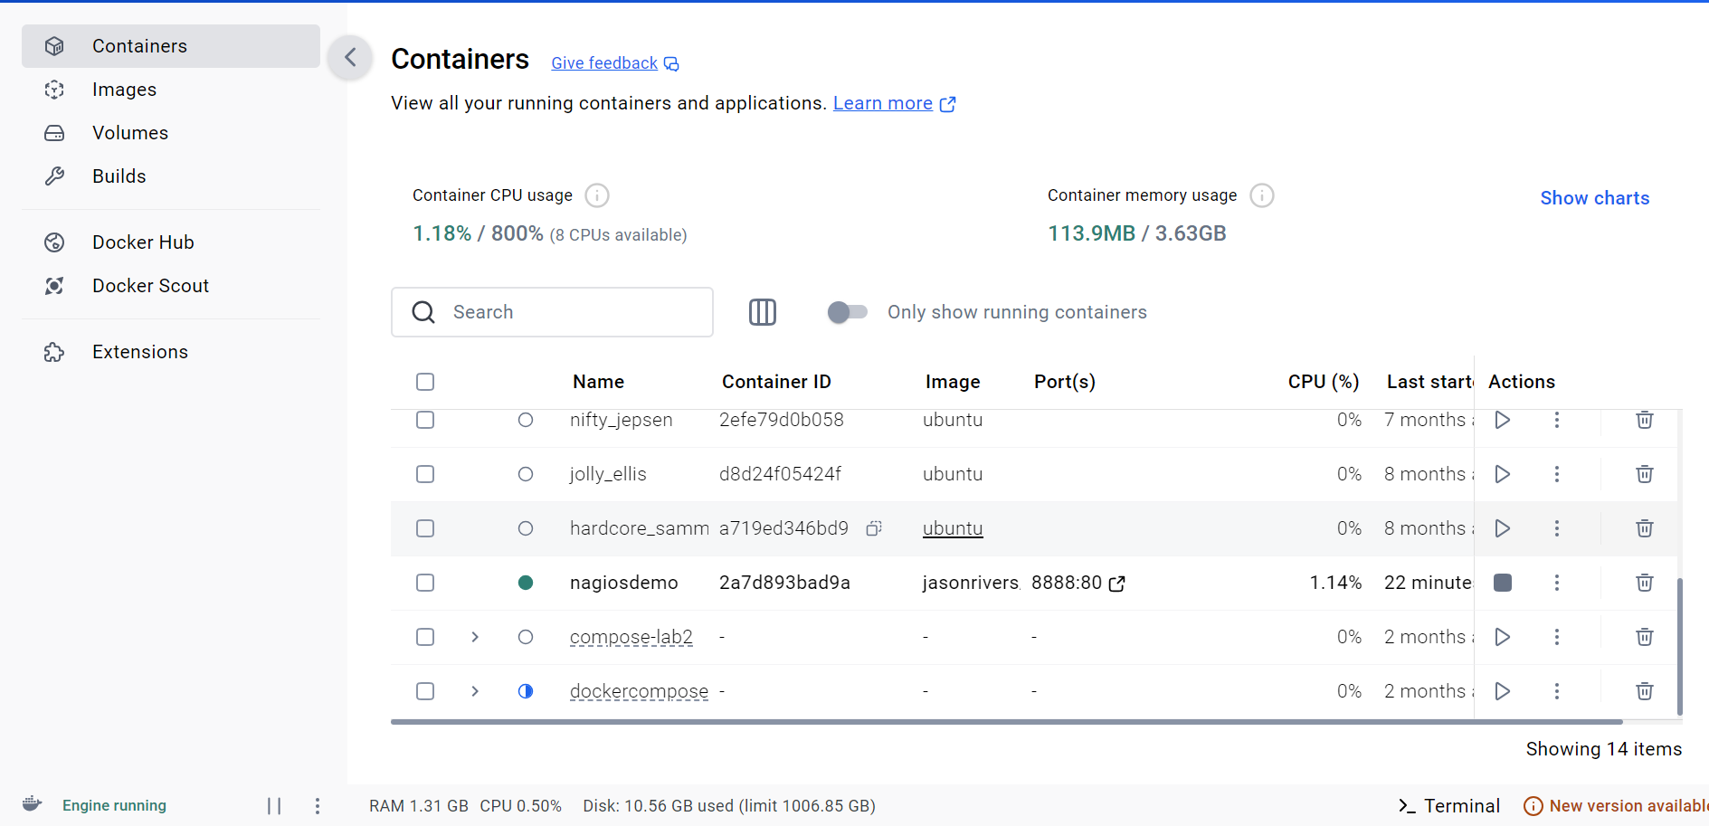

Step 5: Stop and Remove Nagios
- Stop the Container:
  - Command:
docker stop nagiosdemo
- Delete the Container:
  - Command:
docker rm nagiosdemo
- Remove the Image (Optional):
  - List images:
docker images
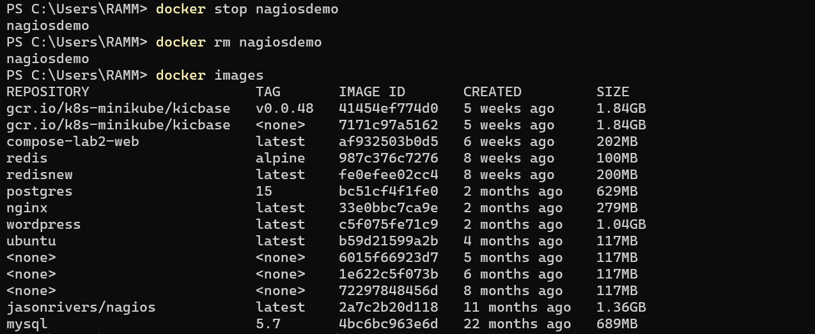
  - Delete the Nagios image:
docker rmijasonrivers/nagios:latest

- Observe the docker containers in DockerHub, we can see the latest Nagios Installed running on port:8888
---------------------------------------------------------------------------------------------------------------------
Steps for AWS-free trier account creation
- open https://aws.amazon.com
- click on create AWS account
- Provide email id and name details for AWS account creation then a screen will appear as below
- Enter verification code received in your mail
- Provide your contact details and agree Terms and conditions, then click on create
- Provide billing details, click on verify and continue
- Amazon chagres 2 rs and it will be credit back into your account once verification is over
- Once payment success a screen appear as below, provide your working contact number after selecting country, and click on send SMS after entering the details
- Provide verification code received in your mobile
- Now select basic plan and click on complete sign up
- Now a screen appear as follows then click on AWS management console
- You will navigating to the aws page ..where you need to Select role as Academic/Researcher and interest as DevOps and click on submit
- Sign into AWS console as Root user
- A console screen appears aws will appear

SBQ’s

- Your Pod keeps restarting repeatedly. What will you do?
kubectl get pods
kubectl describe pod <pod-name> # Check events and restart reason
kubectl logs <pod-name> --previous # View logs of the crashed container

- A Kubernetes pod is stuck in a "Pending" state. What could be the possible reasons, and how would you troubleshoot it?
Reasons:
- Insufficient cluster resources (CPU/memory)
- Node selector or taints/tolerations mismatch
- PVC (PersistentVolumeClaim) not bound
- ImagePull error or lack of permission
Fix:
kubectl describe pod <pod-name>
kubectl get nodes
kubectl get pvc
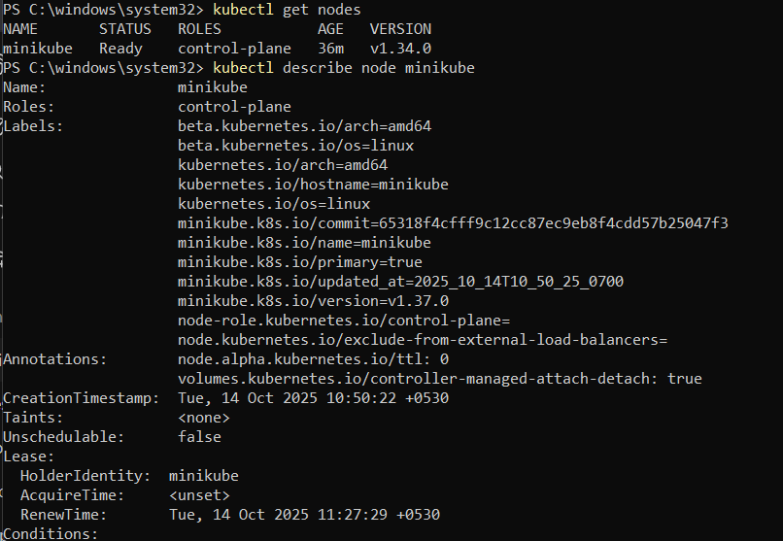
- How would you debug a failed deployment in Kubernetes?
kubectl get deployment
kubectl describe deployment <deployment-name>
kubectl get replicaset
kubectl describe replicaset <rs-name>
kubectl describe pod <pod-name>
kubectl logs <pod-name>
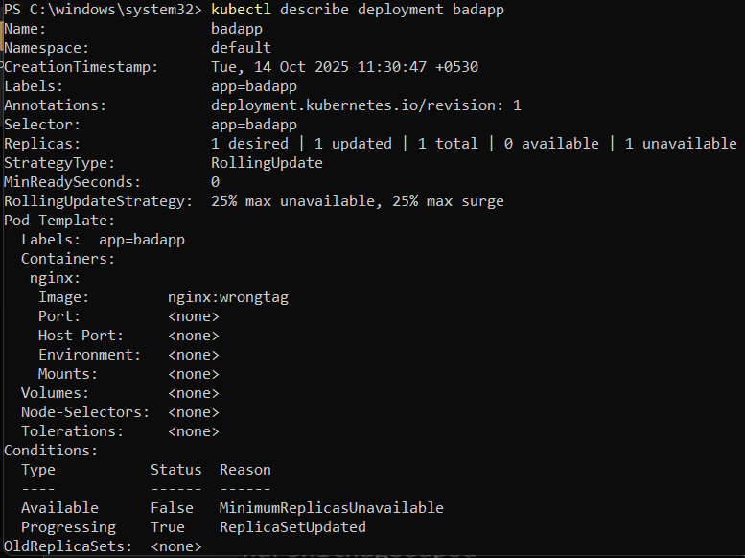
- You have a Kubernetes Deployment with multiple replicas, and some pods are failing health checks. How would you identify the root cause and fix it?
Check pod events and probe results:
kubectl describe pod <pod-name>
kubectl exec -it <pod> -- curl localhost:8080/health

Fix: update probe path, port, or timeout; ensure app serves correct health endpoint.

- How do you roll back a faulty deployment?
kubectl rollout history deployment/<deployment-name>
kubectl rollout undo deployment/<deployment-name>
kubectl rollout status deployment/<deployment-name>

- How do you debug a running Pod?
kubectl exec -it <pod-name> -- /bin/bash # Get inside the container
kubectl logs <pod-name>
kubectl describe pod <pod-name>

- You need to expose a local service externally.How to do?
kubectl expose deployment <deployment-name> --type=LoadBalancer --port=80 --target-port=8080
- How to Start and stop Nagios
docker run --name nagiosdemo -d -p 8888:80 jasonrivers/nagios:latest
docker stop nagiosdemo
docker rm nagiosdemo

- You installed Nagios but the web interface shows “Unable to connect to Nagios process”.how to resolve this?
docker logs nagiosdemo
docker restart nagiosdemo

- You added a new host in Nagios, but it’s not appearing on the web interface.how to check?
nagios -v /usr/local/nagios/etc/nagios.cfg
- How can you check whether Nagios is running properly?
docker ps
Native install: systemctl status nagios
Look for green “Host Up” and “Service OK” states in UI.

- How do you view Nagios logs in real-time
docker logs -f nagiosdemo

- What are the advantages of using Nagios?
- Centralized monitoring of servers, services, and applications
- Alerts via email/SMS when issues occur
- Historical data and performance graphs
- Extensible through plugins
- Supports both agent-based and agentless monitoring
- Scalable for enterprise use with distributed setups

